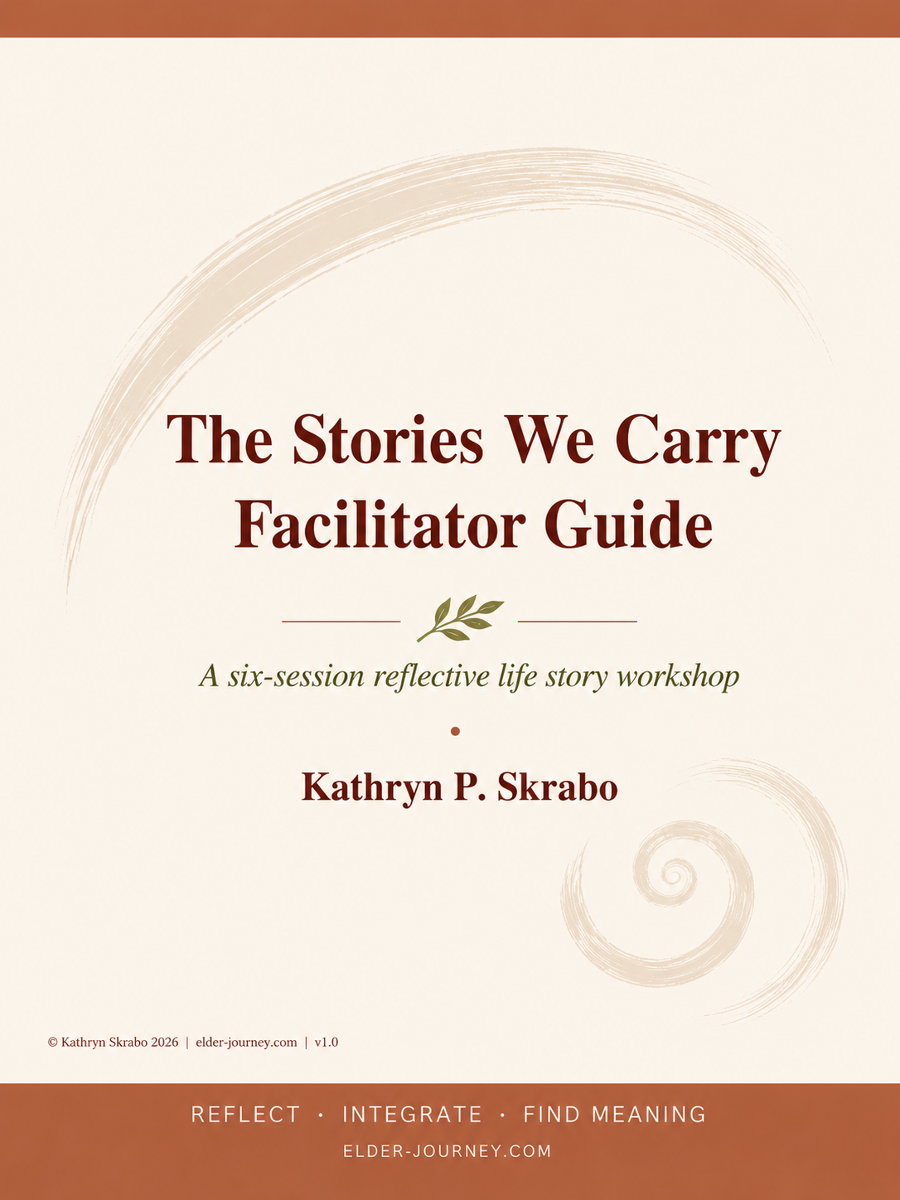
Purpose of This Guide

This guide provides the conceptual foundation and structural overview for The Stories We Carry, a six-session reflective life story course designed for older adults.
It is not intended to train facilitators in basic group process. Rather, it clarifies the architecture, pacing, and intention of the class so that seasoned facilitators can confidently guide participants through a process of reflection and meaning-making.
It is assumed that these sessions will be tailored to meet the needs of your group. Variables such as number of participants will affect timing and flow. The scripted curriculum provided should be adapted as needed.

Why a Lifespan Structure and Developmental Frame

Many older adults naturally return to familiar or emotionally charged periods of their life—often keeping the story narrow. A lifespan arc widens the narrative beyond familiar stories by inviting attention to less-explored chapters and overlooked transitions.
Participants are invited to see their lives as adaptive and evolving systems rather than fixed stories. Instead of emphasizing reminiscence or the retrieval of specific memories, the focus is on how individuals have grown, adapted, and made meaning across the lifespan.
The course invites participants to explore their lives not simply as a sequence of memories, but as a developmental journey. The facilitator’s role is to create an environment where patterns, insights, and coherence can emerge naturally through reflection and shared experience.

Later Life Is Especially Suited for This Work
Later life often brings psychological capacities that can support reflective work. These capacities allow individuals to revisit earlier experiences not simply as memories, but as parts of a larger developmental story. The emphasis shifts from accumulation to integration—from what happened to what it means. These capacities support the shift from recounting events to interpreting them.
The benefit of having lived many years provides greater emotional perspective and increases tolerance for complexity and ambiguity. When exploring key developmental processes, the ability to recognize long-term patterns and themes becomes apparent.

Session 2 | Adolescence: Becoming & First Return

The Container
- Purpose:
  - To explore adolescence as a formative period of identity development and as the first major return
  - To introduce the Spiral as a way of understanding how meaning evolves over time

- Developmental Focus:
  - Adolescence and identity formation
  - First reinterpretation of earlier experience
  - Emergence of self-awareness
  - Beginning of narrative reflection across time

- Session Arc: Adolescence $→$ Identity $→$ Spiral $→$ Reflection

- Materials Needed: Participants' photographs from adolescence or early adulthood, copies of The Spiral Integration Lifelong Path and the Spiral Integration Reflection tool

1. The Welcome & Photograph Check-In (15 Minutes)
Facilitator Note Welcome participants back. This check-in uses the photo they were asked to bring to anchor the shift into adolescence.
Speak Welcome back everyone. For the next four sessions, we will be using the photographs you bring to connect directly with the time period we are discussing. Let's begin our group check-in using the photo you brought today.

Inquiry Prompt
Please share your photograph and offer 2–3 words that describe what that time of life felt like.

2. Adolescence as the First Point of Return (15 Minutes)
Facilitator Note Help the group notice how early threads evolve into questions, values, and tensions. Adolescence is the first major “return”—the first time we are able to reinterpret childhood from a new vantage point, and the first conscious use of symbols (music, aesthetics, journals, style) to shape an identity that is emotionally charged and personally defining.
Speak Adolescence is a time when many of the early threads of our identity begin to take shape. It is a critical period of identity formation marked by rapid physical, emotional, and social changes. At the time, we rarely understand how significant certain experiences will become, but later in life we can look back and see those moments differently.
Adolescence is often remembered as a time of change, exploration, and growing independence, but it is also often the first time we have experiences that echo across the decades. It is our first major 'returning' to our story. We see meaning now that may not have been visible then.
Adolescence and elderhood make a powerful pairing because they are both identity-forming stages, but in opposite directions: Adolescence asks, 'Who am I becoming?' while Elderhood asks, 'Who have I become?’
Inquiry Prompt
Think of a meaningful experience from your adolescence or early adulthood that has resurfaced at different points in your life.
- What happened?
  - How did it affect you at the time?
  - How do you understand it now?

3. Introduction to the Spiral Metaphor (20 Minutes)
Facilitator Note The Spiral provides a visual metaphor for adult development. Rather than viewing life as a straight line of stages left behind, it suggests that individuals will revisit earlier questions and experiences with new awareness. Through reflection, earlier events take on new meaning, unresolved experiences become integrated, patterns across the lifespan become visible, and a deeper sense of coherence emerges.
Speak We often think of life as a straight line—moving forward from one stage to the next, much like the Life Graph we started last week. But human experience doesn’t actually unfold that way. We return to earlier questions. We revisit earlier versions of ourselves. We reinterpret moments that once felt settled.
This is why the Spiral is such a powerful metaphor. The Spiral is not just a concept—it’s a lived experience. We grow by circling back, we deepen by returning, and we evolve by revisiting the places that shaped us. You’ve already felt it
- when an old memory suddenly makes new sense
- when a childhood value reappears later in life
- when a long-held question resurfaces with new clarity
- or when you realize you’ve been circling around the same theme your whole life
Inquiry Prompt
Looking at the adolescent version of you in the photo:
  - What is one thing you understand now that you couldn’t have known then?
  - What stands out to you as you look back on adolescence now?
  - Do you see connections between your younger self and who you are today?

4. Adaptation, Integration, and the Reflection Tool (15 Minutes)
Facilitator Note This process is not just about "telling your life story," but about "understanding how your life developed." Participants return to earlier experiences not to relive them, but to reinterpret them through the perspective of later life. This primes the core idea of the Spiral: continuity and change in motion and returning to earlier material with new capacities.
Speak The spiral reflects the ongoing process of adaptation and integration across our lifespan. Adaptation is a lifelong rhythm; we adapt, recalibrate, and reinterpret our experiences again and again. Three ideas help us understand this:
- Life transitions are recursive: We revisit earlier developmental tasks in new forms.
- Meaning evolves: What something meant at 20 may mean something entirely different at 70.
- Identity is dynamic: We are always in the process of becoming.
This is why later life is such a powerful time for reflection. We finally have the distance to see the long arc of our lives as a Spiral of return.
Inquiry Prompt
Reflect on one quality you possess that has remained consistent since adolescence, and one quality that has evolved significantly.

Facilitator Note Distribute the Spiral Integration Lifelong Path and Spiral Integration Reflection Tool. Explain that it is not an assessment, but a reflective tool to notice shifts. After each session, they should take a minute in a notebook or on a separate piece of paper to capture what surfaced, what is seen differently, their connections across time, and the perspective gained. Track what emerges. This will be helpful for the final Life Map we will do in session 6.

5. Closing (5 Minutes)
Facilitator Note Bring the session to a unified close, linking the work of Session 1 to today's work.
Speak In our first session, we were Gathering the Threads—noticing small but meaningful memories, images, or sounds that still shimmer after many years. Today, we officially entered the Spiral: Becoming. We began seeing the past through new eyes, revisiting earlier experiences from a later vantage point and noticing how meaning changes with time. As we look back at adolescence with this new perspective, we begin to uncover the patterns, turning points, and influences that were previously unavailable to us.

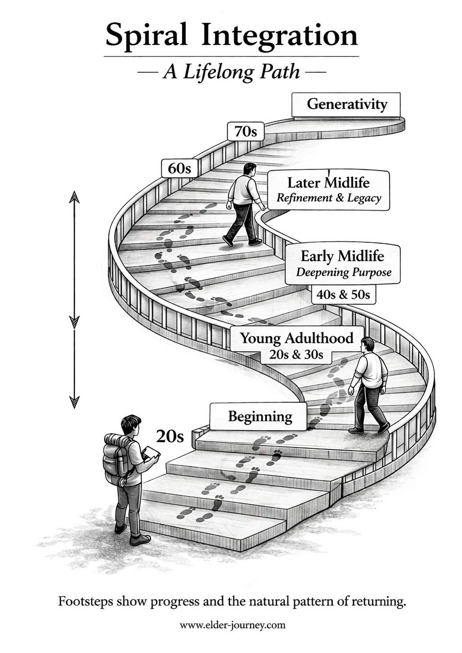
Handout
Spiral Integration Reflection Tool

Purpose

The Staircase Spiral is not an assessment, rather, it serves as a reflective tool—allowing you to notice shifts as you move through your life. After each session, take a minute to capture some of your reflections. Use a separate piece of paper for each session. At the end of the class, we will do a life map. These reflections will be helpful to refer back to.
Reflection Questions Session Number ______

- Landmarks - What surfaced? (e.g., a move, a career change, or a shift in a relationship
Identify the moments, memories, thresholds, or “shimmers” that emerged during this session. Look at the photograph you brought. What moment in your life does it represent?
What do you remember about who you were then?

- The Return (Seeing it differently)
What do you notice now, with your present awareness, that you could not see at the time?

- The Thread (Connecting across the Spiral)
Does this pattern appear elsewhere in your life? where?

- Narrative Maturity (The Vantage Point)
What compassion, understanding, or wisdom can you offer your younger self from where you stand now?

